Elephant Herding Optimization
Seminar report
Elephant Herding Optimization (EHO) searches for a low value of an objective function by updating a group of candidate solutions. This report explains the update rules in Chapter 12, shows how the Python code implements them, and uses a simulated two-pump system to demonstrate how the same algorithm can solve a different problem.

1 Problem and representation
A candidate is a vector of numbers. The objective function turns that vector into a score, called fitness. The goal in this project is to minimize the score. The Rastrigin benchmark in Section 12.5 has many local minima, so a point can look good in its immediate neighborhood even when a better point exists elsewhere. Its global minimum has fitness zero at the origin.
The chapter introduces clans led by matriarchs. The MATLAB and C++ listings store candidates in a matrix, with one complete candidate per row and one coordinate per column. The Python version uses that layout. For example, a population of five candidates in four dimensions has five rows and four columns. The objective evaluates each row as a whole.

2 How one generation works
The algorithm first samples candidate positions within the lower and upper bounds and evaluates their fitness. It records the best position found so far, called pbest, and keeps the index of the row that found it. Each generation reads the previous population when producing new positions.
For a regular candidate, Equation (12.1) uses x′ = x + α × (pbest − x) × r. Here x is one old coordinate and r is a uniform random draw. The coefficient α controls how far the coordinate can move toward pbest. For the leader row, the code averages each coordinate across the old population to find its center, then scales that center by β. These are Equations (12.3) and (12.2), respectively.
The worst candidate receives a new position from Equation (12.4), x′ = L + r × (U − L + 1), where L and U are the bounds for that coordinate. The extra 1 can put a sampled coordinate above U. The implementation preserves the formula and records these cases. When the leader and worst are the same row, the leader update takes priority, following the order of the branches in the listings.

3 Block flow and source code
The loop follows Algorithm 11 and the branch order in Listings 12.1 and 12.2. After scoring the new positions, the code finds the current best and worst. It replaces the saved best position, score and leader index only when the score improves. The worst row is recalculated each generation, and the saved leader index can differ from the current best row. The run ends at the generation limit or after a stop request.
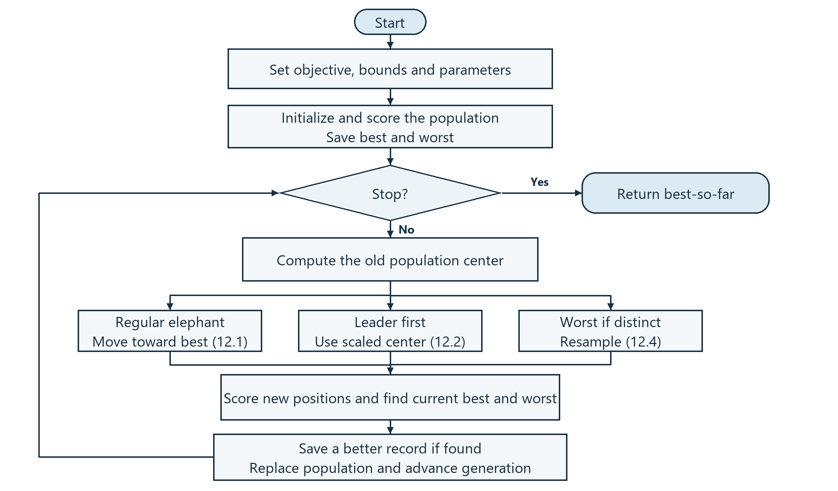

Where the work happens in Python
src/eho/optimizer.py runs the loop and records the results. src/eho/operators.py applies the three update rules. src/objectives/rastrigin.py implements the benchmark in Equation (12.5), and src/objectives/book_replay.py recomputes the worked example. The GUI in src/gui starts the same optimizer in a worker thread and uses the recorded positions to display each step.
The book replay checks 26 printed values within rounding tolerance. It recomputes the later fitness values from the coordinates printed in Section 12.5. The book omits the random draws needed to reconstruct the movements of candidates x4 and x5 independently.

4 Application to two pump flow rates
The application models a station with two pumps that must supply a target flow while keeping operating cost low. Each candidate contains two flow rates, q₁ and q₂, in m³/h. The Normal Demand scenario targets 70 m³/h. Pump 1 can supply up to 65 m³/h and pump 2 up to 55 m³/h. The model uses simulated costs and demand settings.

Objective function
PumpScenario in src/objectives/pump_allocation.py assigns each pump an operating cost of a × q² + b × q, where q is its flow rate and a and b are coefficients from the scenario file. The objective adds 5 × shortage², 2 × excess², and 100 times the sum of squared distances outside the pump bounds. Since the demand target is expressed as a penalty, the lowest-scoring candidate can have a small shortage.
Experiment/Experiment 4.ipynb already runs this application with Low, Normal and Peak Demand from data/pump_scenarios.csv. It compares EHO with an 81 × 81 grid search within the pump limits. The grid provides a reference score from the points it samples. The EHO loop and update rules are the same ones used for Rastrigin.

Normal Demand demo
With 20 candidates, 50 generations and seed 42, EHO proposed 40.70 and 29.12 m³/h. Both pumps stayed within their individual limits. Their total flow was 69.82 m³/h, about 0.18 m³/h below demand. The total score was 86.7148, including a shortage penalty of about 0.1678. The grid reference scored 86.5969.
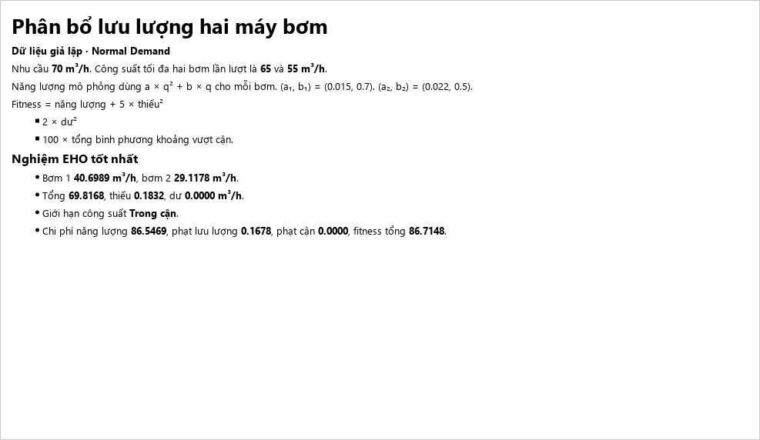

5 Rastrigin demo
The two-dimensional Rastrigin run used five candidates, 50 generations, α = 0.5, β = 0.1 and seed 42. It evaluated 255 candidates, including the initial population. The best fitness fell from 31.2939 to 0.00937, at approximately (−0.00121, −0.00676).
The screenshot shows the move from generation 0 to generation 1. Open circles mark old positions and solid dots mark new positions. The star marks the best position available before that step. The blue arrow follows the leader update, the brown arrow shows the resampled worst candidate, and the gray arrows show regular updates.
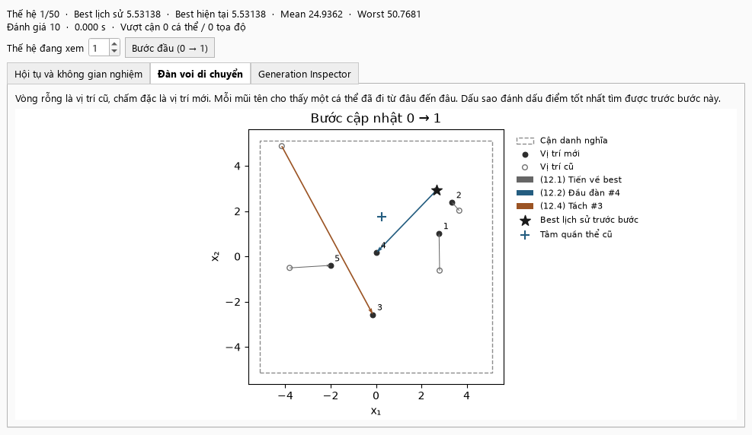
To reproduce the demo, run python main.py, select Rastrigin with two dimensions, and use Start followed by the first-step button. For the pump run, select Pump Allocation and Normal Demand, set the population to 20, and open Application after the run finishes.

Reference
Meena, N. K., Yang, J., and Slowik, A. “Elephant Herding Optimization.” In Swarm Intelligence Algorithms: A Tutorial, edited by Adam Slowik, CRC Press, Chapter 12, pp. 149–162. See Sections 12.2–12.5, Algorithm 11, Listings 12.1–12.2 and Equations (12.1)–(12.5).

